**Project Name - Manage Café Employees**

**GitHub Repository URL**

https://github.com/gamunua/U3InfoTech-CafeEmployees.git

**Principles**

Solid Principles

**Design Patterns**

Mediator Pattern

CQRS

DRY

KISS

**Front End**

ReactJS with Vite build tool

**Solution Folder**

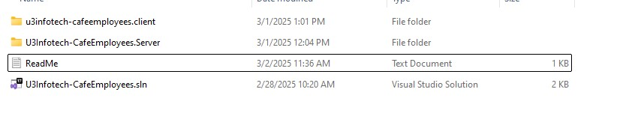

**API Project - .NET** 8

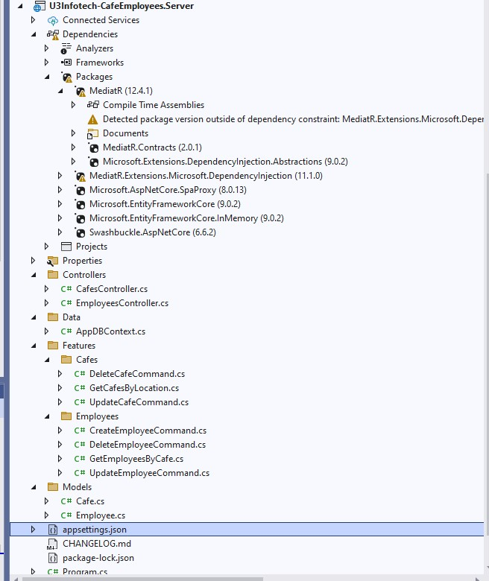

API details

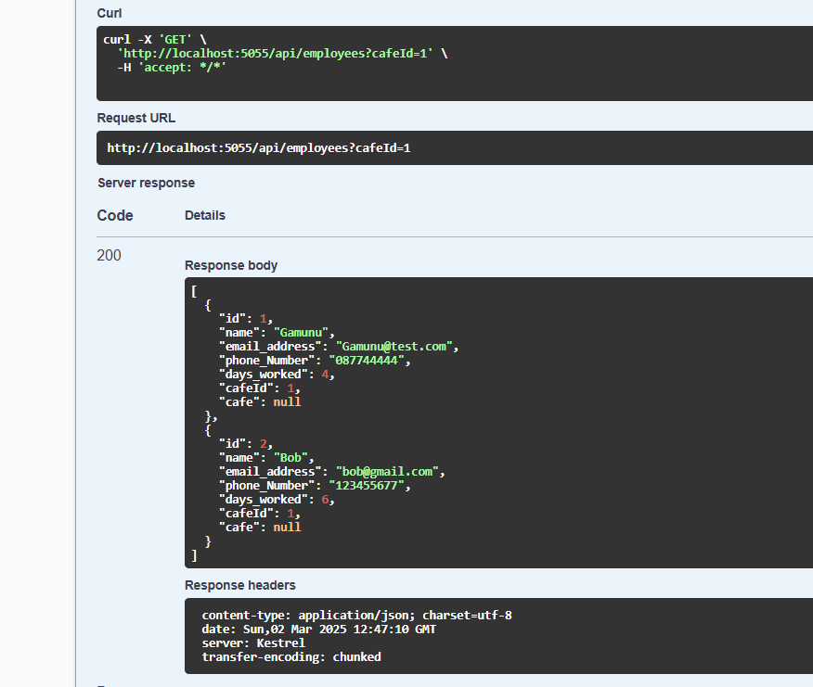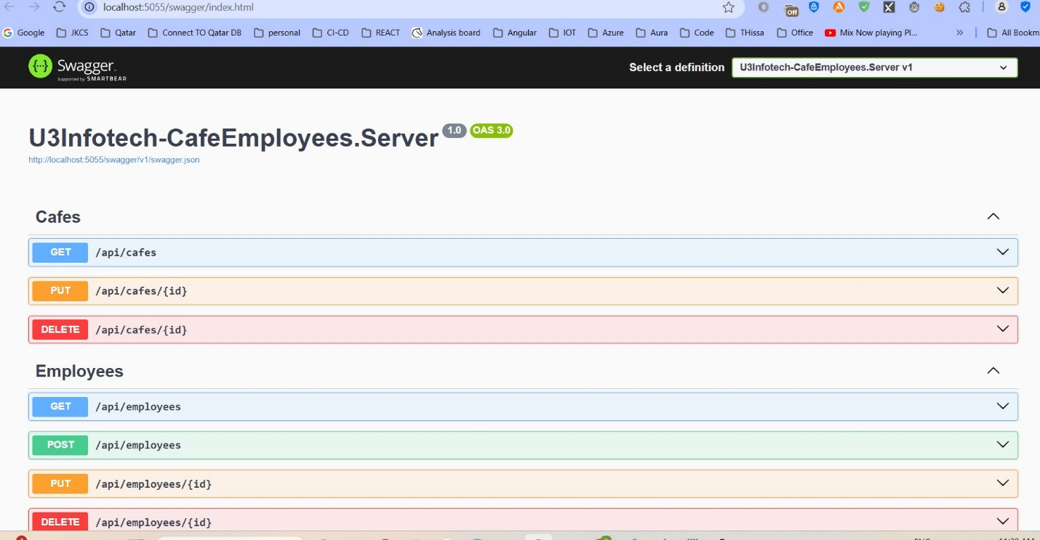

**DB Seed Details**

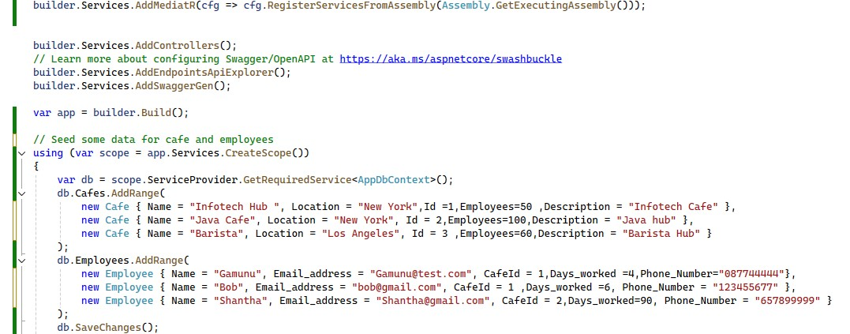

**Front End Details**

